Aim: Deploying Applications, CI/CD Pipeline, and Cluster Monitoring

Theory:
1. Kubernetes Architecture & Workload Management
Kubernetes (K8s) is an open-source container orchestration platform designed to automate the deployment, scaling, and operation of application containers across clusters of hosts.

A. Structural Hierarchy: Deployment ➔ ReplicaSet ➔ Pods
- Pod: The smallest deployable unit in Kubernetes. A Pod encapsulates one or more closely coupled containers (e.g., application container + sidecar), shared storage volumes, and a unique cluster IP address.
- ReplicaSet: A controller whose primary role is to maintain a stable set of replica Pods running at any given time. If a node fails or a container crashes, the ReplicaSet guarantees self-healing by instantiating new Pods.
- Deployment: A higher-level abstraction that declaratively describes desired application state. Deployments manage the creation, rollouts, rollbacks, and lifecycle of underlying ReplicaSets without downtime.
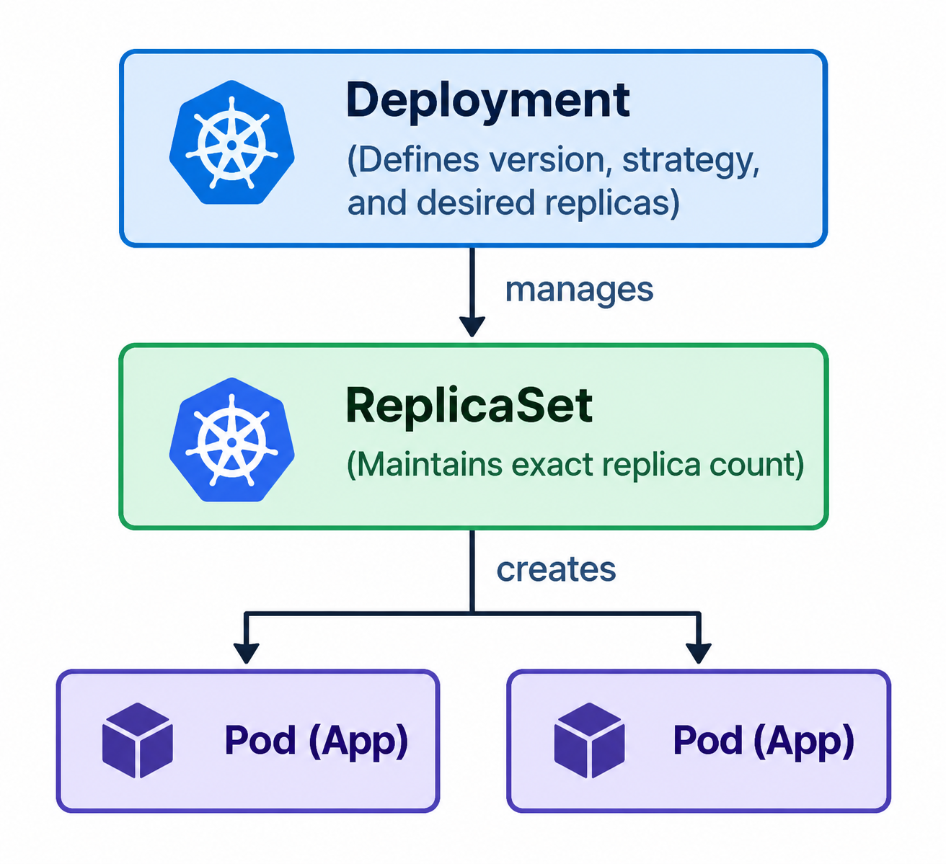

B. Declarative vs. Imperative Management
- Declarative (kubectl apply -f manifest.yaml): The user writes a YAML manifest specifying the desired state. The Kubernetes control plane continuously runs a reconciliation loop to align current cluster state with this desired state.
- Imperative (kubectl scale --replicas=5): Commands issued directly via CLI telling the cluster what specific action to perform immediately.

2. CI/CD Pipeline Automation with GitHub Actions & Docker (CO5)
Modern DevOps practices emphasize automated pipelines to minimize human error, standardize software builds, and accelerate production deployments.

A. Continuous Integration (CI) & Continuous Delivery (CD)
- Continuous Integration (CI): Developers commit code frequently to a shared repository. Automated processes validate every commit by compiling code, running automated tests, and building container images.
- Continuous Delivery/Deployment (CD): Automated deployment of built artifacts to a staging or production container registry (e.g., Docker Hub) and orchestration environments (e.g., Kubernetes).

B. GitHub Actions Pipeline Components
- Workflows (.github/workflows/*.yml): Configurable automated procedures made of one or more jobs, triggered by repository events (e.g., git push origin main).
- Runners: Virtual machines (e.g., ubuntu-latest) provisioned on-demand by GitHub to execute workflow jobs in isolated environments.
- Docker Buildx: An extended Docker CLI plugin leveraging the BuildKit engine, providing advanced features like multi-architecture builds, build cache optimization, and secret mounting.
- Secret Management: Sensitive credentials (such as Docker Hub Access Tokens) are encrypted using Libsodium and stored as GitHub Actions Secrets. They are dynamically injected at runtime without being exposed in source control or console logs.

3. Kubernetes Cluster Monitoring & Resource Management (CO6)
Cluster observability is essential for diagnosing performance bottlenecks, planning infrastructure capacity, and detecting application failure.

A. Resource Specifications: requests vs. limits
Every container manifest should specify compute requirements:
- Resource Requests (cpu: "100m", memory: "128Mi"): The minimum guaranteed amount of CPU and Memory the scheduler uses to decide which node can accommodate the Pod.
- Resource Limits (cpu: "250m", memory: "256Mi"): The hard ceiling on compute consumption:
  - CPU Limits: CPU is a compressible resource; if a container exceeds its CPU limit, the Linux kernel throttles its execution (CFS Quota).
  - Memory Limits: Memory is an incompressible resource; if a container exceeds its memory limit, the Linux kernel terminates the process with an Out Of Memory (OOMKilled - Exit code 137) signal.

B. Kubernetes Metrics Server
The Metrics Server is a cluster-wide aggregator of operational data. It collects resource utilization metrics directly from the cAdvisor (Container Advisor) agent embedded within the kubelet on each node.
- Exposes metrics via the metrics.k8s.io API.
- Powers native CLI inspection (kubectl top nodes, kubectl top pods).
- Serves as the data backbone for the Horizontal Pod Autoscaler (HPA) and graphical web dashboards (Minikube Dashboard / Grafana).

Task 1: Application Deployment & Replica Scaling
1. Applied Manifest & Initial Inspection (2 Replicas)
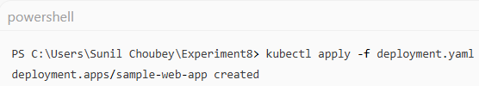
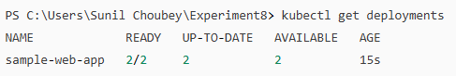
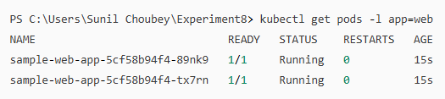
2. Scaled to 5 Replicas
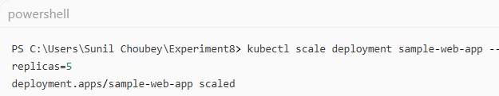
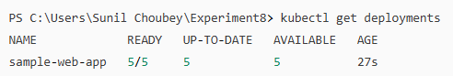
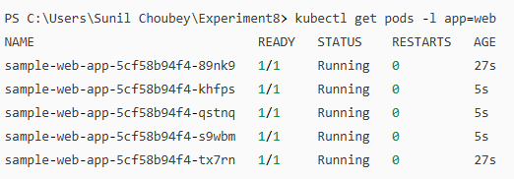
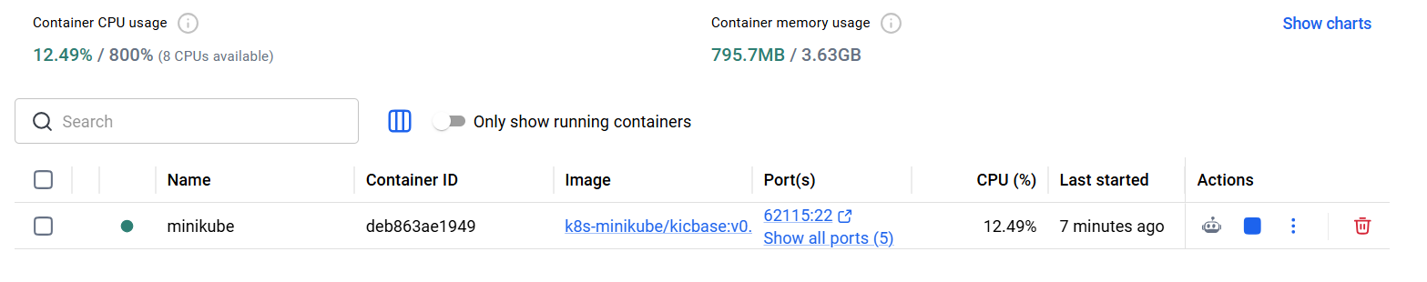
Task 2: CI/CD Pipeline Automation with GitHub Actions
Github Repo link : Flipped classroom

Completed green run in GitHub Actions workflow history.
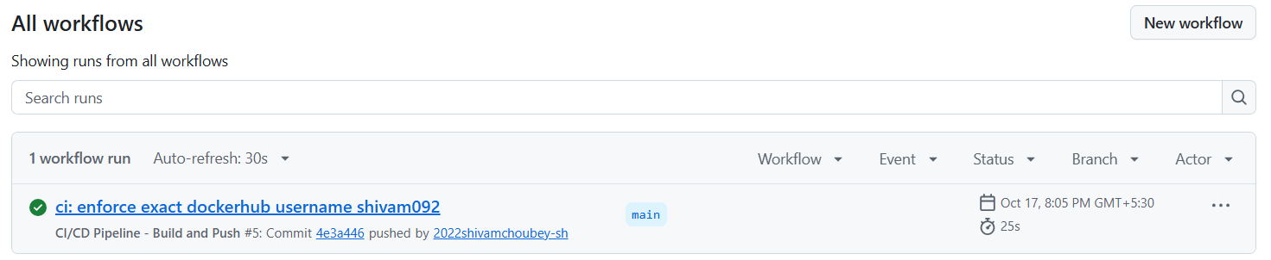
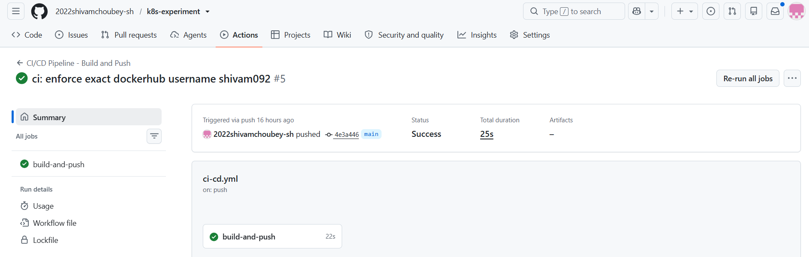
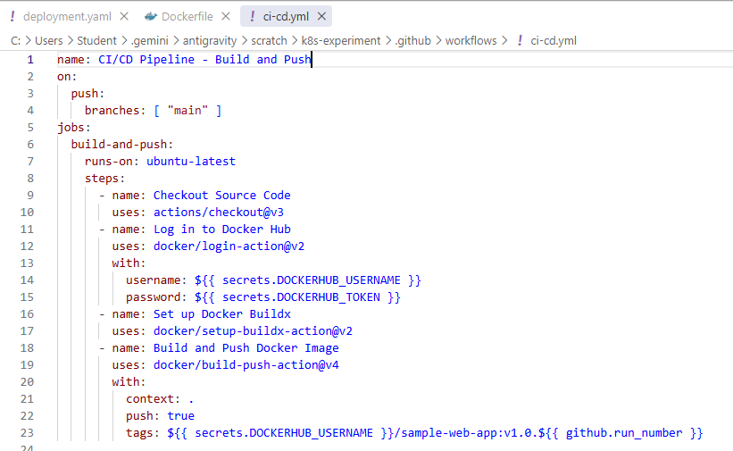

Live interactive logs
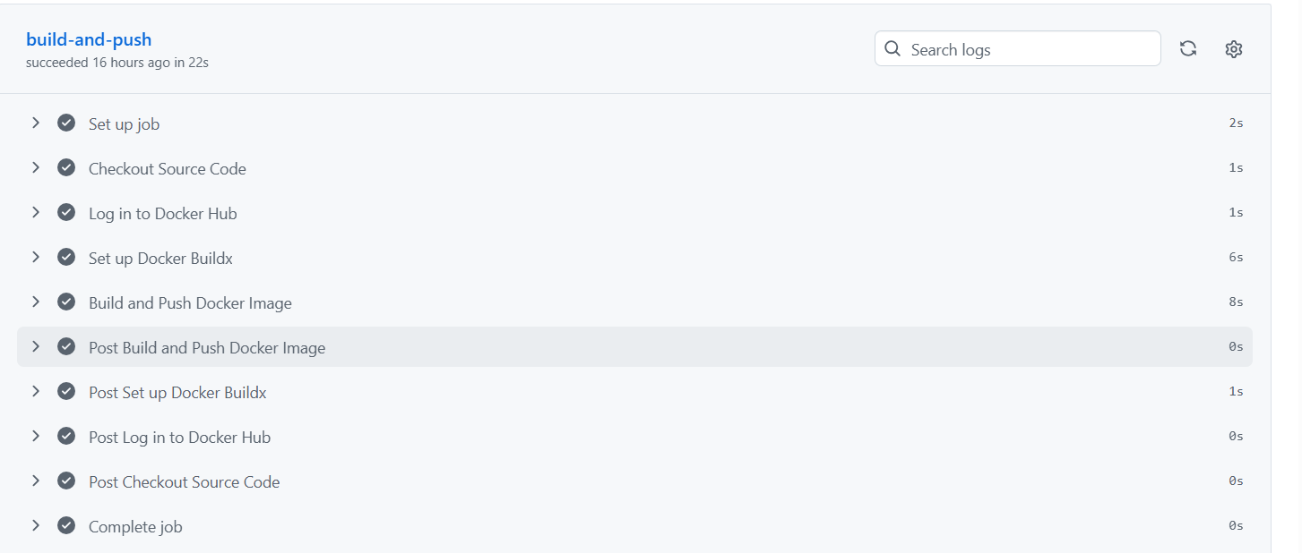

Resulting Docker Image
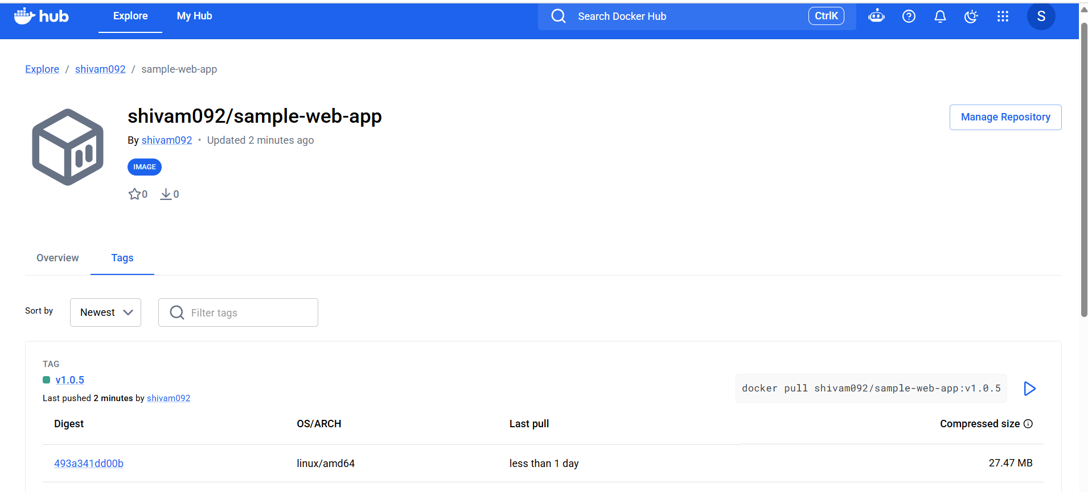

Task 3: Cluster & Pod Monitoring (CO6)
1. Node & Pod Resource Metrics (kubectl top)
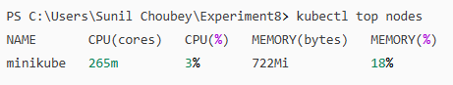

2. CLI Resource Utilization Monitoring (kubectl top)
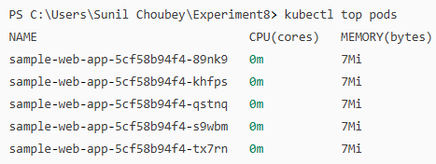

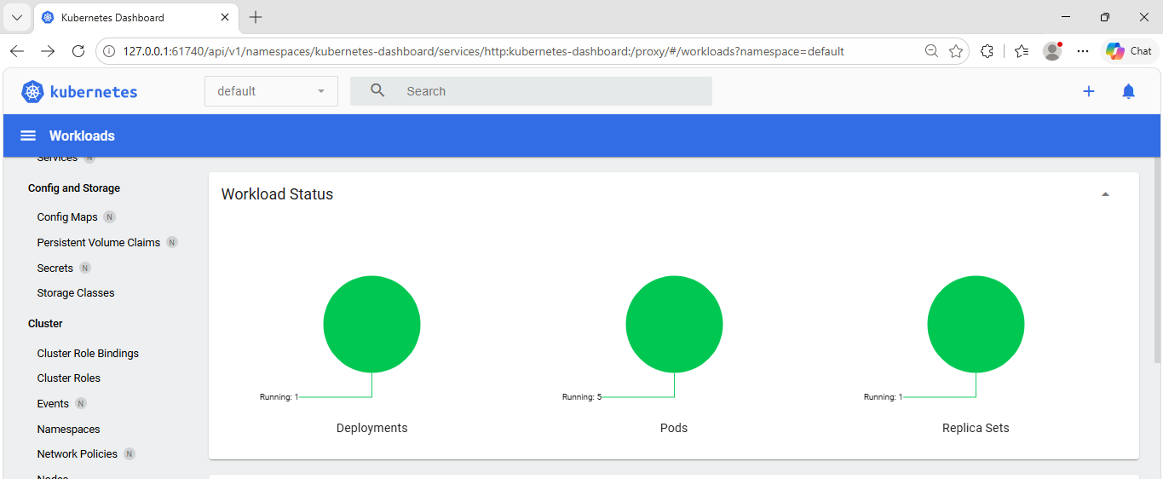
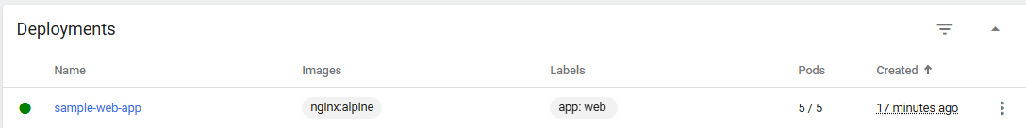
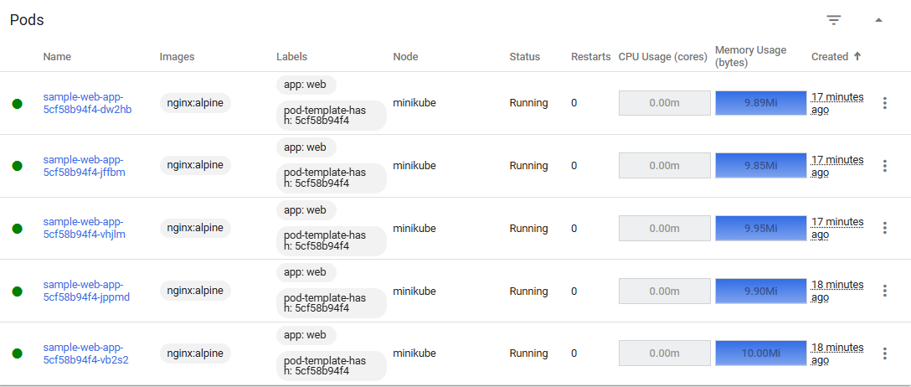

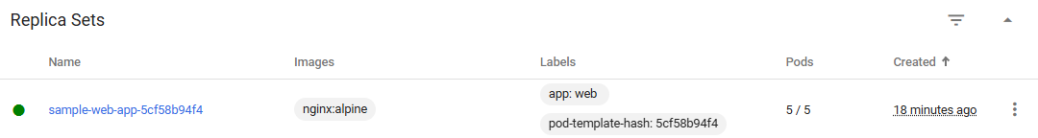
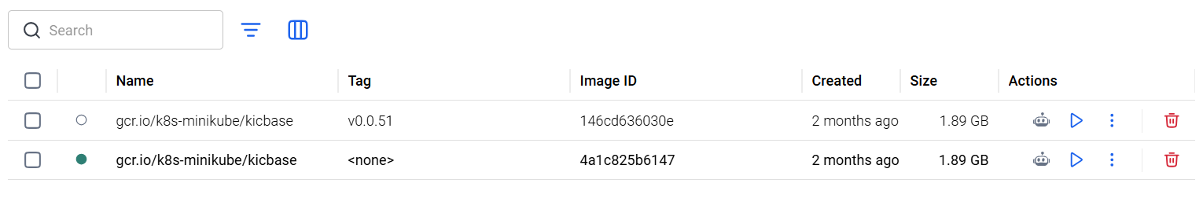

Phase 3: Post-Lab Reflection Questions

Q1: How can you update ci-cd.yml to automatically run kubectl apply against your Kubernetes cluster
after pushing a new image tag?
→Add a Continuous Deployment (CD) step to ci-cd.yml that authenticates to the Kubernetes cluster
using a KUBECONFIG secret stored in GitHub Actions, and executes kubectl set image
deployment/sample-web-app web-container=shivam092/sample-web-app:v1.0.${{ github.run_number }} (or
kubectl apply -f deployment.yaml).

Q2: What happens when a container exceeds its limits.memory specification? How would Grafana signal
this alert?
→When a container exceeds its memory limit, the Linux kernel terminates its process with an OOMKilled (Out
Of Memory Killed, Exit code 137) error, causing Kubernetes to enter a CrashLoopBackOff state. In
Grafana/Prometheus, this triggers an alert rule when container_memory_working_set_bytes exceeds
the memory limit threshold or when the container_oom_events_total counter increments.

Conclusion:
Successfully deployed a containerized web application on a local Kubernetes cluster using Minikube, configured declarative scaling to 5 replicas, automated the container build and delivery pipeline using GitHub Actions and Docker Hub, and analyzed real-time cluster resource metrics using Kubernetes Metrics Server and Minikube Dashboard.

